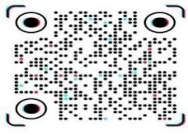


scrotal Ultrasound Report
- Patient Name: Jawad Age: 30 years Date: 29-10-2026

FINDINGS:
- RIGHT TESTIS:
Measures 42 × 28 × 25 mm, with Normal size, echogenicity, and parenchymal echotexture. No focal lesion is seen. Volume: 16ml.
- LEFT TESTIS:
Measures 40 × 25 × 28 mm, with Normal size, echogenicity, and parenchymal echotexture. No focal lesion is seen. Volume: 15ml.
- VASCULARITY:
Normal blood flow is noted in both testes.
- EPIDIDYMIS:
Both epididymis appear normal.
- HYDROCELE:
No hydrocele is seen on either side.
- VARICOCELE:
Normal. No varicocele noted.
- INGUINAL REGIONS:
No inguinal hernia is seen on either side.

IMPRESSION:
Normal testicular Doppler ultrasound study.

Signature: Signature: signature:
Dr. Abdus salam Dr. Sher wali khan Mr. Atta ur Rahman
MBBS, FCPS RADOLOGY Consultant Andro urologist Ms. Ultrasound

